Is this human gene robbery?
M. D. NAIR

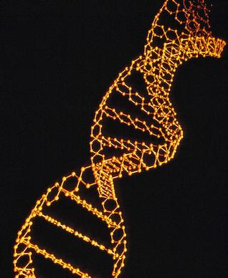
An intricate ethical and legal issue.

Patenting life forms, including DNA, raises ethical concerns.
The recent judgment of the US Supreme court against patenting of the cancer genes BRCA1 and BRCA2, has met with mixed responses from biotechnology companies, medical activists and the general public. These have been used in diagnostic kits by the Utah-based Myriad Genetics for determining the genetic disposition for ovarian and breast cancers in high-risk women. Most people have welcomed the order under the impression that this vital technology will now be available in the public domain, at affordable costs. The revelations of actor Angelina Jolie that she underwent radical bilateral mastectomy as a prophylactic step after she tested positive in Myriad’s genetic screening further evoked interest in the case. Whether Jolie’s bravado is a model for others with similar risk levels to follow is a moot point. .
Leading biotechnology companies feel a blanket denial of patents on genes and DNA sequences is a retrograde step, since it will slow down interest and investment in the development of new drugs through application of gene-based genetic technologies.

WHAT’S PATENTABLE?
The question of whether life forms in general are patentable subject matter has been debated for the last three decades. The TRIPS agreement which deals with members’ commitment to honouring the Intellectual Property Rights (IPR) system itself, is silent on this, except to say that plant varieties need to be protected either through the patent system or a sui generis system, and microorganisms (without defining the term) need to be provided protection.
Member countries of the WTO have, therefore, the freedom to allow or disallow the patenting of natural life forms including genes, DNA sequences, naturally occurring microorganisms or natural products in general, in their national patent laws.
Many members distinguish discovery from invention. The US Supreme Court judges ruled that while the natural genes isolated from living matter are not patentable, any converted gene or DNA, whether it is composite or complementary, which involves ingenious and inventive manipulation through scientific intervention, would qualify for the patent.
Even in the case of the Myriad patents (there are around two dozen of them), only claims referring to natural genes have been disallowed. Thus, it is fair to assume that the court’s ruling will not, in any way, affect Myriad’s commercial interests or further innovations, or for that matter, genetic research for the development of new diagnostics, prophylactics or therapeutics.

WHOSE GENES?
A much more important issue is ownership of the concerned genes and the rights of individuals or communities from whom the genes have been isolated. Several major ethical and legal issues have surfaced on the issue of commercially exploiting human tissues without the knowledge, let alone prior informed consent, from donors. Over the years, such exploitation has been rampant among medical researchers and pharmaceutical companies.
The well known case of John Moore who sued the University of California for using his surgically removed diseased spleen to develop commercially useful diagnostic kits, without paying any royalty, was decided by the California court in favour of the University. The court ruled that the subject from whom a tissue or organ has been surgically removed has no ownership rights over them and hence is not entitled for any reward from the commercial use of any product developed from them. Even in the case of BRCA1 and BRCA2, the question remains as to whose tissue samples were used for their isolation and whether their ownership has been clearly established, recognised or rewarded. The Convention on Biodiversity stipulated at the Rio conference in 1992 that owners of biological material have to be duly recognised and rewarded if they are utilised for commercial purposes. Yet, no fair and equitable system of compensation is in place.

